**FEP Stakeholder Meeting Agenda**

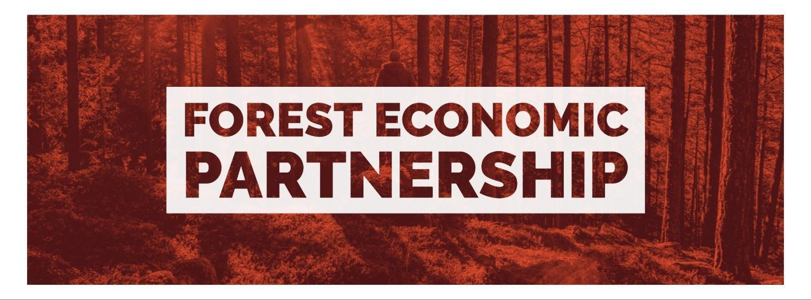

Wednesday 12th June 2024

17:00 – 18:30

AccXel Construction School, Whimsey Industrial Estate, Cinderford, GL14 3JA

1. **Arrival, refreshments & networking** (17:00-17:15)
2. **Welcome & announcements** (Neill Ricketts)
3. **Apologies** – Deborah Flint
4. **Guest speakers and Q&A** (Ian Mean)

* The Music Works – Khady Gueye & Issachar Foster
* Canopy Creative Network – Rob Olins
* Dean Forest Radio – Mark Jones
* FVAF – Deb Cook
* Forest of Dean & Wye Valley Tourism – Paul Williamson
* AccXel – Natalie King

1. **FEP Board governance & finances** (Wendy Jackson)
2. **Education and Skills subgroup update** (Clare Vertigen)
3. **Net Zero & Climate Action subgroup update** (David Trevelyan)
4. **Celebrating Success project** (Rebecca Clay)
5. **Meeting close at 18:30**

**Future meeting dates**

* Wednesday 11th September 5:00 – 6:30pm
* Wednesday 4th December 5:00 – 6:30pm